Session 10
1.
Create two tables: Influencers (id, name) and Collaborations (id, influencer1_id, influencer2_id, collab_date). Write a SQL FULL JOIN query to list all influencers and show their collaboration partner names if any, including influencers with no collaborations.
Ans :
SELECT
i1.name AS influencer,
i2.name AS collaboration_partner,
c.collab_date
FROM Influencers i1
LEFT JOIN Collaborations c
ON i1.id = c.influencer1_id
LEFT JOIN Influencers i2
ON c.influencer2_id = i2.id

UNION

SELECT
i1.name AS influencer,
i2.name AS collaboration_partner,
c.collab_date
FROM Influencers i2
LEFT JOIN Collaborations c
ON i2.id = c.influencer2_id
LEFT JOIN Influencers i1
ON c.influencer1_id = i1.id;

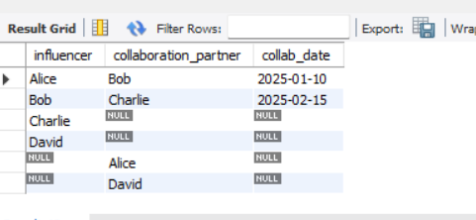
2.
Using a SELF JOIN, write a query on a table called Playlists (id, user_id, playlist_name, parent_playlist_id) to display each playlist alongside its parent playlist name, similar to how Spotify shows nested playlists.<br><br><em><strong>Hint:</strong> Join Playlists with itself on parent_playlist_id = id.</em>
Ans :
SELECT
p1.playlist_name AS Playlist,
p2.playlist_name AS Parent_Playlist
FROM Playlists p1
LEFT JOIN Playlists p2
ON p1.parent_playlist_id = p2.id;

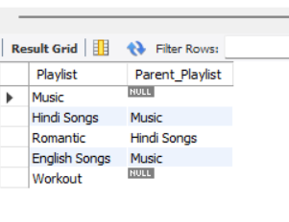

3. Given three tables: Users (id, username), Orders (id, user_id, order_date), and Payments (id, order_id, amount), write a SQL query using multiple JOINs to display each username, their order date, and payment amount, showing all users even if they have no orders or payments.
Ans :
SELECT
u.username,
o.order_date,
p.amount
FROM Users u
LEFT JOIN Orders o
ON u.id = o.user_id
LEFT JOIN Payments p
ON o.id = p.order_id;
4.
You notice that your JOIN query between Zomato's Restaurants and Reviews tables is returning duplicate rows for some restaurants. Modify your query to eliminate duplicates and explain in one line why the duplicates were happening.<br><br><em><strong>Hint:</strong> Use DISTINCT or GROUP BY and consider the relationship between restaurants and reviews.</em>
Ans
SELECT
r.restaurant_name,
AVG(rv.rating) AS Average_Rating
FROM Restaurants r
LEFT JOIN Reviews rv
ON r.id = rv.restaurant_id
GROUP BY r.restaurant_name;

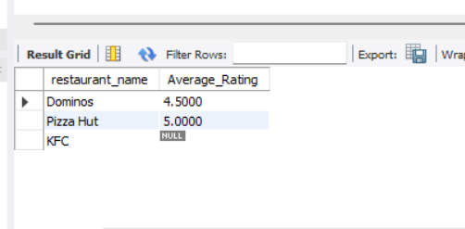
5.
Write two different JOIN queries on a Products and Categories table (like Flipkart) to list all products with their category names, but use different join conditions in each. Briefly explain which join condition is more efficient and why.
Ans :
SELECT
product_name,
category_name
FROM Products
INNER JOIN Categories
USING (category_id);
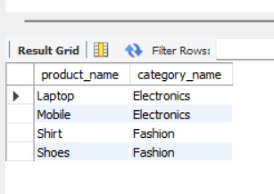

SELECT
p.product_name,
c.category_name
FROM Products p
INNER JOIN Categories c
ON p.category_id = c.category_id;
